
Mawlana Bhashani Science and Technology University
Sontosh, Tangail-1902
Department of Information and Communication Technology

Lab Report

Lab Report no : 05
Name of the report : Different Types of Joining Operation.
Course title : Database Management System Lab
Course code : ICT-2110

Submitted By | Submitted To
Name: Monirojjaman Ayoive  ID: IT-23013  2nd Year, 1st Semester  Session: 2022-2023  Dept. of ICT, MBSTU | Dr. Md. Abir Hossain  Associate Professor  DEPARTMENT OF INFORMATION AND COMMUNICATION TECHNOLOGY  MAWLANA BHASHANI SCIENCE AND TECHNOLOGY UNIVERSITY
Date of Performance: 07-01-2025 Date of Submission: 24-01-2025

Experiment No: 05
Experiment Name : Different Types of Joining Operation.
Objectives: The main objective of this experiment is to use different types of join in MySQL. We will learn how to join two tables using different types of joining. And also learn how to use joining with condition to find desire values.
Required Instruments:
- MySQL 9.0 Command line Client.
For the purpose of joinig, a student table is created and data has been inserted in that table.
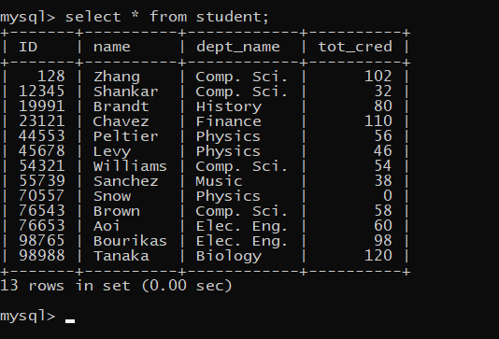
For the purpose of joinig, another takes table is created and data has been inserted in that table.
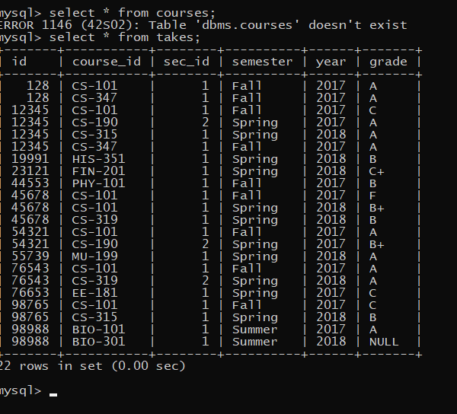

Inner join:
SQL expression: select name, dept_name, year, grade from student inner join takes;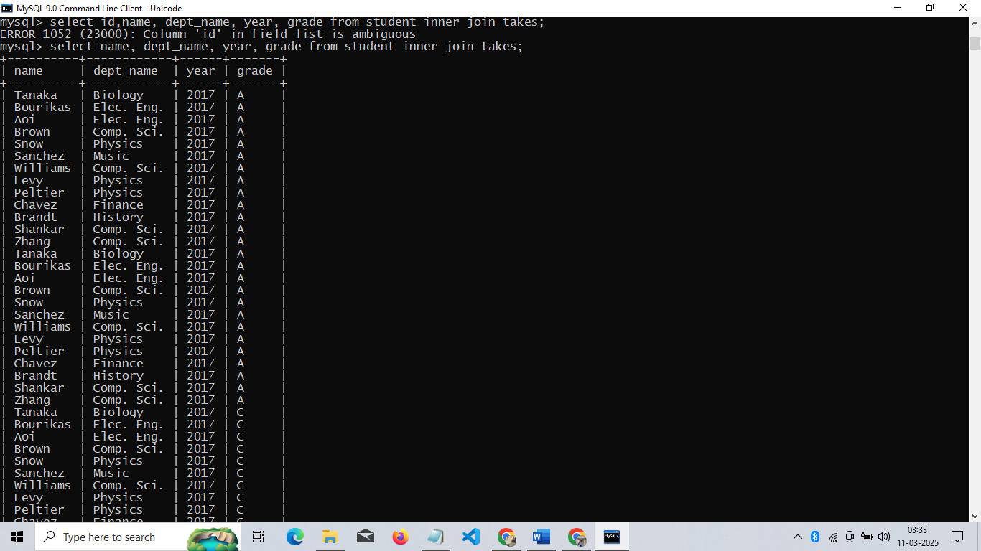
Here, this query selects the name, dept name, year, and grade by joining the student and takes tables
Takes
Student
ID

select name, dept_name, year, grade from student inner join takes;
SQL expression: select name,dept_name, year, grade from student inner join takes on student.ID=takes.ID;
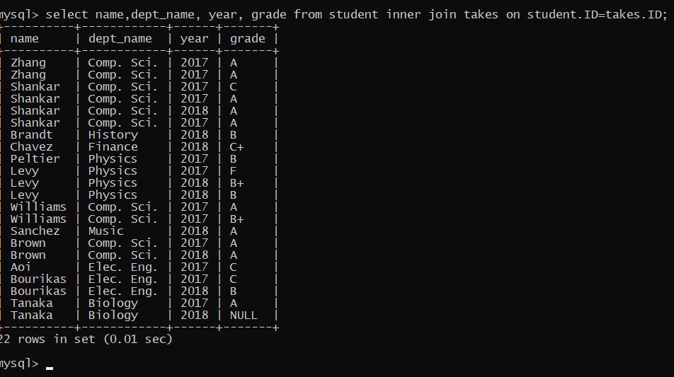

Here, This query selects the department name, budget, classroom’s room number, and classroom’s capacity by joining the two tables (department and classroom) based on shared “building” field. This will return data only where the department and classroom are located in the same building.
Takes
Student
ID

SQL expression: select name, course_id, salary,year from instructor inner join teaches on instructor.ID = teaches.ID;
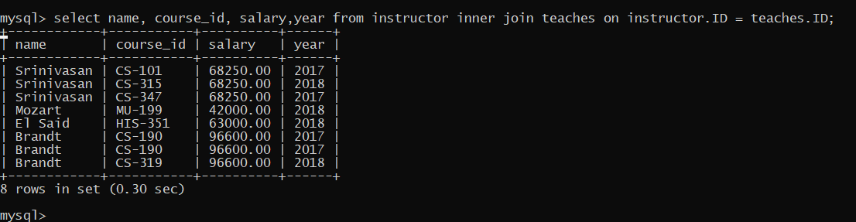
This query selects the instructor's name, course ID, salary, and the year they taught the course, joining the instructor and teaches tables using the common ID field.

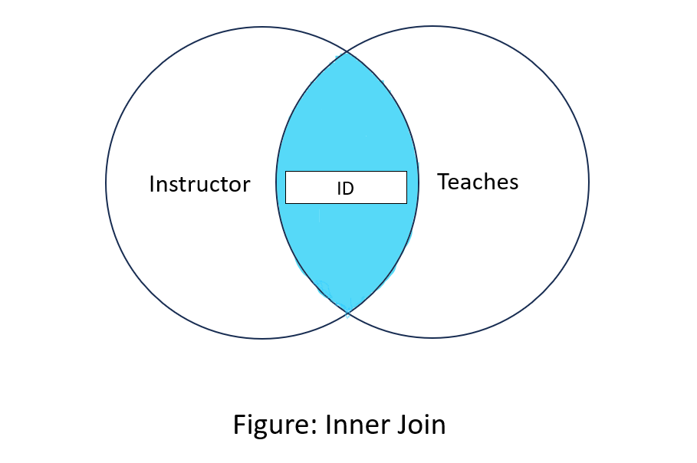

Left join:
SQL expression: select instructor.ID, instructor.name, department.building from instructor left join department on instructor.dept_name=department.dept_name;
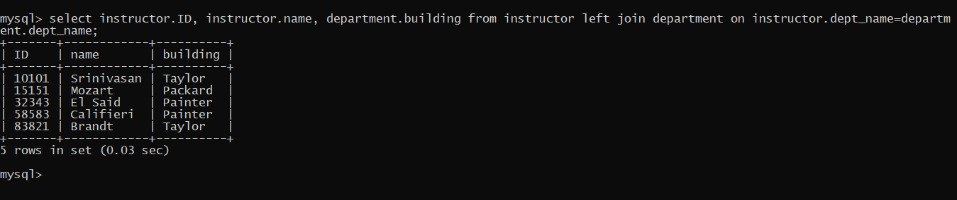
This query performs a left join between the instructor and department tables based on the “dept_name” field. The left join ensures that all records from the instructor table are included, even if there’s no corresponding entry in the department table.
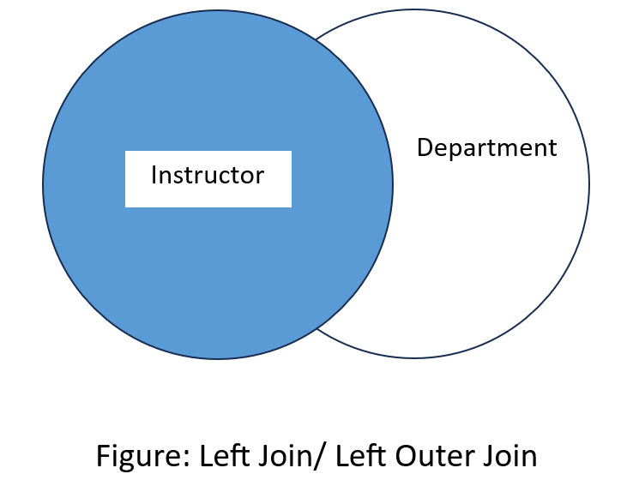

Right join:
SQL expression: select teaches.course_id, teaches.sec_id, instructor.name from teaches right join instructor on teaches.ID=instructor.ID;
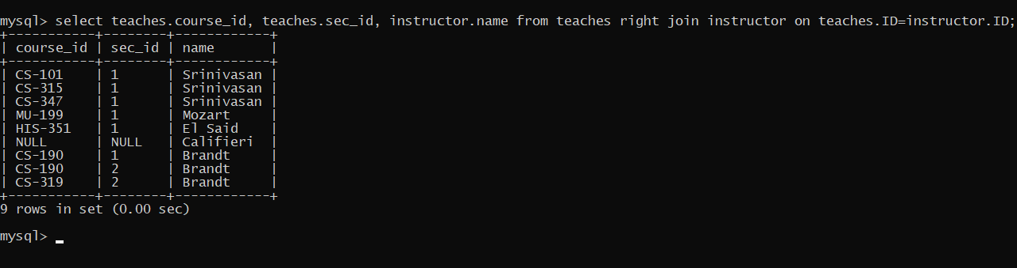
This query uses a Right Join, which ensures that all rows from the instructor table are returned, even if there is no matching ID in the teaches table. If no match is found, the course_id and sec_id from the teaches table will be NULL.
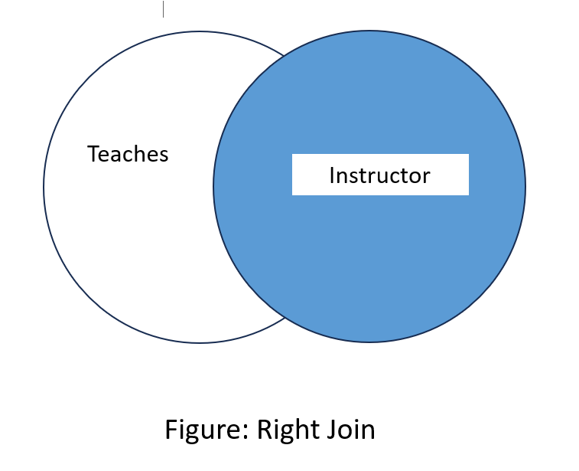

Full join:

SQL expression: select * from department left join course on department.dept_name = course.dept_name union select * from department right join course on department.dept_name = course.dept_name;
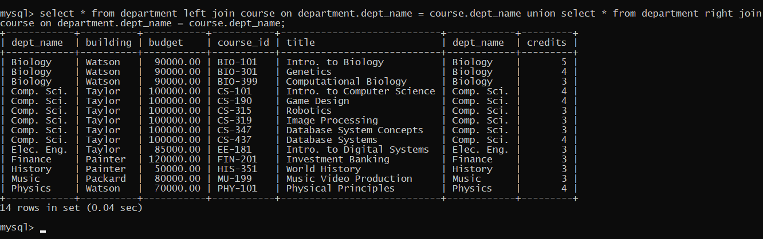
The above query is a full join that combines the results of two different joins—LEFT JOIN and RIGHT JOIN—using the UNION operator. This allows you to retrieve all unique rows from both joins meaning it will have all the data from both course and department.
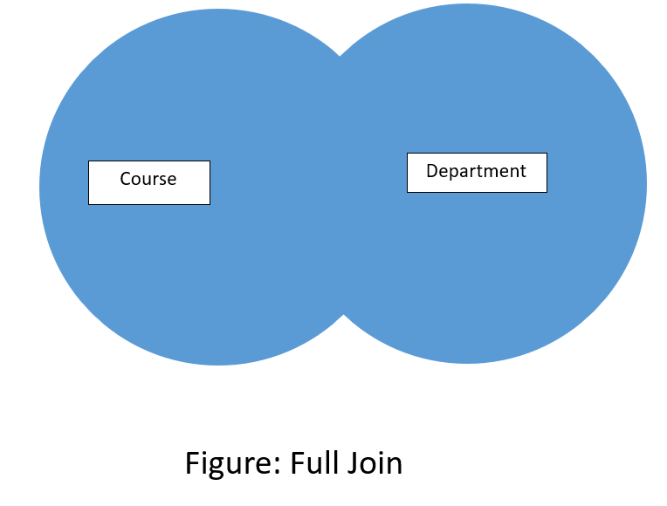
SQL expression: select * from instructor left join teaches on instructor.ID = teaches.ID union ; select * from instructor right join teaches on instructor.ID = teaches.ID;
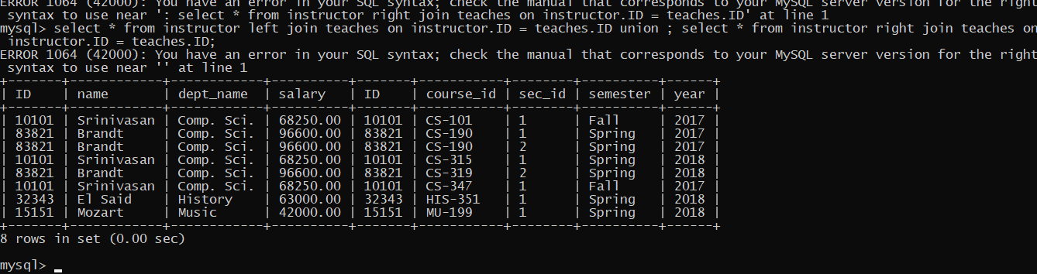
The above query is a full join that combines the results of two different joins—LEFT JOIN and RIGHT JOIN—using the UNION operator. This allows you to retrieve all unique rows from both joins meaning it will have all the data from both teaches and instructor.

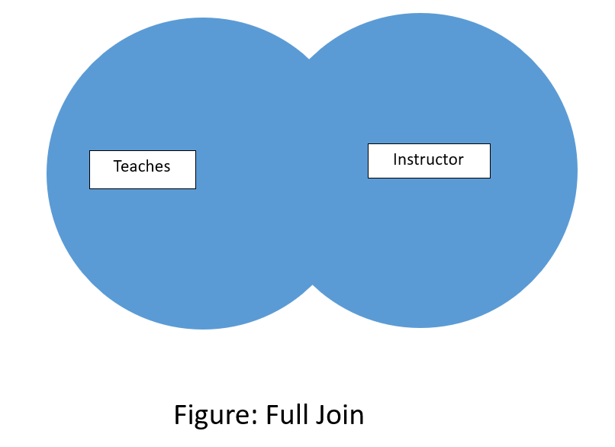

Natural join:
SQL expression: select name, dept_name from student natural join takes;
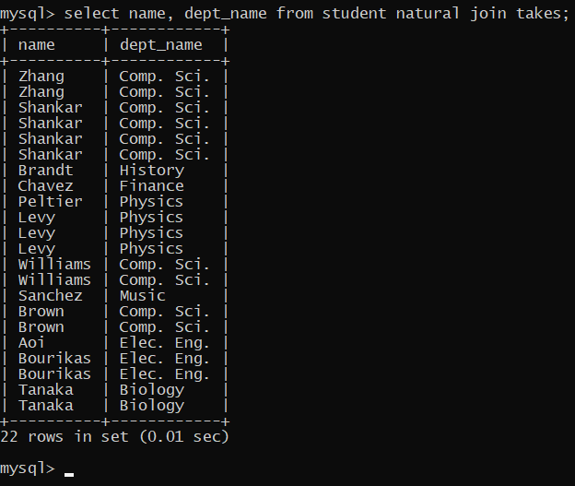
This SQL query is a natural join which will combine the department and classroom tables based on the common columns that has the same in both department and classroom.
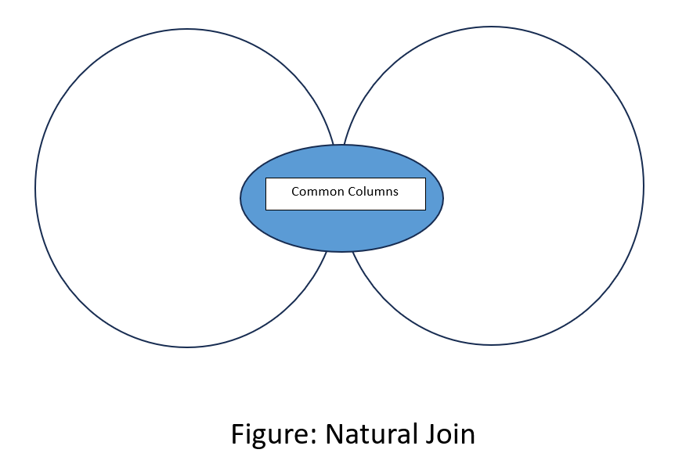

SQL expression: select name, ID, dept_name, semester,year from instructor natural join teaches;
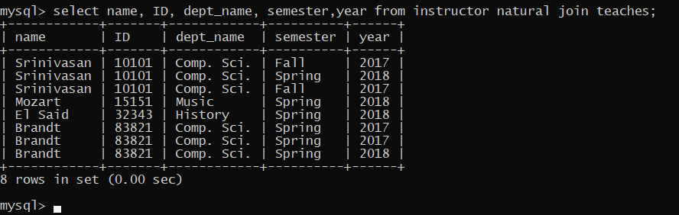
This SQL query is a natural join which will combine the department and classroom tables based on the common columns that has the same in both instructor and teaches.

SQL expression: select course_id, title, room_number, time_slot_id from course natural join section;
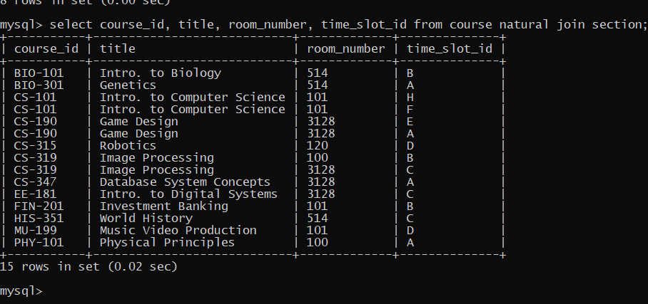
This SQL query is a natural join which will combine the department and classroom tables based on the common columns that has the same in both course and section.


Discussion: Using the above queries we can use various types of joining like inner join, left join, right join, natural join, full join to find desire data from databases.

